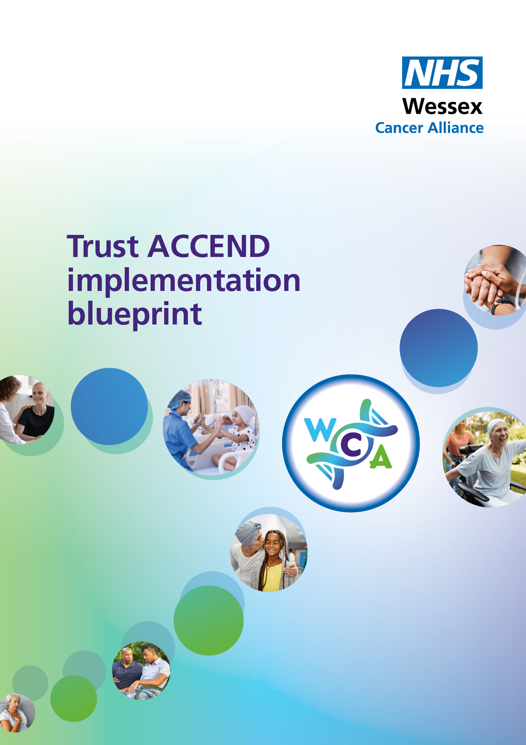

Supporting the implementation of the ACCEND Framework within organisations – Terms of Reference

ACCEND Steering Group
TERMS OF REFERENCE
PROGRAMME/PROJECT | ACCEND Framework
DATE AGREED
VERSION NO.
DATE REVIEWED
REVIEW DUE
AUTHOR

1 | INTRODUCTION
 | The ACCEND Steering Group provides strategic oversight and leadership for the implementation of the ACCEND framework, ensuring a coordinated, high-quality approach to cancer education, capability development, and workforce transformation across professions and settings. Bringing together clinical leaders, educators, system partners, and AHP representatives, the group works to support consistent adoption of ACCEND, address emerging challenges, share best practice, and guide regional priorities that strengthen the cancer workforce and improve patient care.
2 | OBJECTIVES
The ACCEND Steering Group has been established to:
- Review each element of ACCEND Framework and plan how it can be implemented within the organisation in the agreed timeline.
- Explore how ACCEND can be communicated to different teams, acknowledging different levels of practice.
- Collaborate with Wessex Cancer Alliance (WCA), including use of
existing resources to support implementation.
- Provide a mechanism for joint action and joint decision-making for implementation issues that are best addressed collaboratively.
- Promote the objectives of ACCEND across the wider Trust.

3 | RESPONSIBILITIES
The Group will take joint responsibility for the implementation of ACCEND by:
- Ensuring education and workforce strategies support the ACCEND principles.
- The group will work collaboratively with colleagues from WCA to guarantee the successful integration of the framework in the Trust.
- The responsibilities are to:
- Agree plans and take action to ensure translation of the framework.
- Ensure implementation and evaluation are carried out within an agreed timeframe.
- Oversee and monitor progress in delivering the implementation of ACCEND.
- Encourage innovative thinking, new approaches and improvement in the delivery
of the framework.
- Act as a forum for the facilitation and promotion of active learning.
- Create a forum whereby best practice, including quality, safety and patient
involvement, can be shared.
- Provide a forum for problem solving collectively and peer support.
4 | ACCOUNTABILITY
 | The ACCEND Steering Group is accountable is to the X.
5 | MEMBERSHIP
- For membership please refer to appendix 1, membership.
- Members are expected to attend meetings on a regular basis. Where this is not possible the chair will review and seek alternative representation.
- Representatives from other departments and organisations will be invited to the meeting relevant to agenda items.
6 | QUORUM
- Meetings of the ACCEND Steering Group shall be quorate if there is representation from the chair, or their nominated deputy and X (complete as agreed)
- The ACCEND Implementation Lead is responsible for preparing the agenda and will collate and circulate papers to members. Unless otherwise agreed by the Chair, the agenda and papers should be circulated not less than 1 week before the meeting.
- The ACCEND Steering Group may be transacted in person or on Teams. At the start of each meeting taking place without all parties physically present, the Chair shall be responsible for determining that the meeting is quorate.
7 | FREQUENCY AND DURATION
 | - Agree locally
8 | OUTPUTS AND REPORTING
- Meeting notes and actions to be taken and circulated following each meeting.
- The Group will report to the Wessex Cancer Alliance ACCEND Steering Group and provide highlights and return agreed reporting metrics

Appendix (1) Members

Complete as appropriate for your organisation

