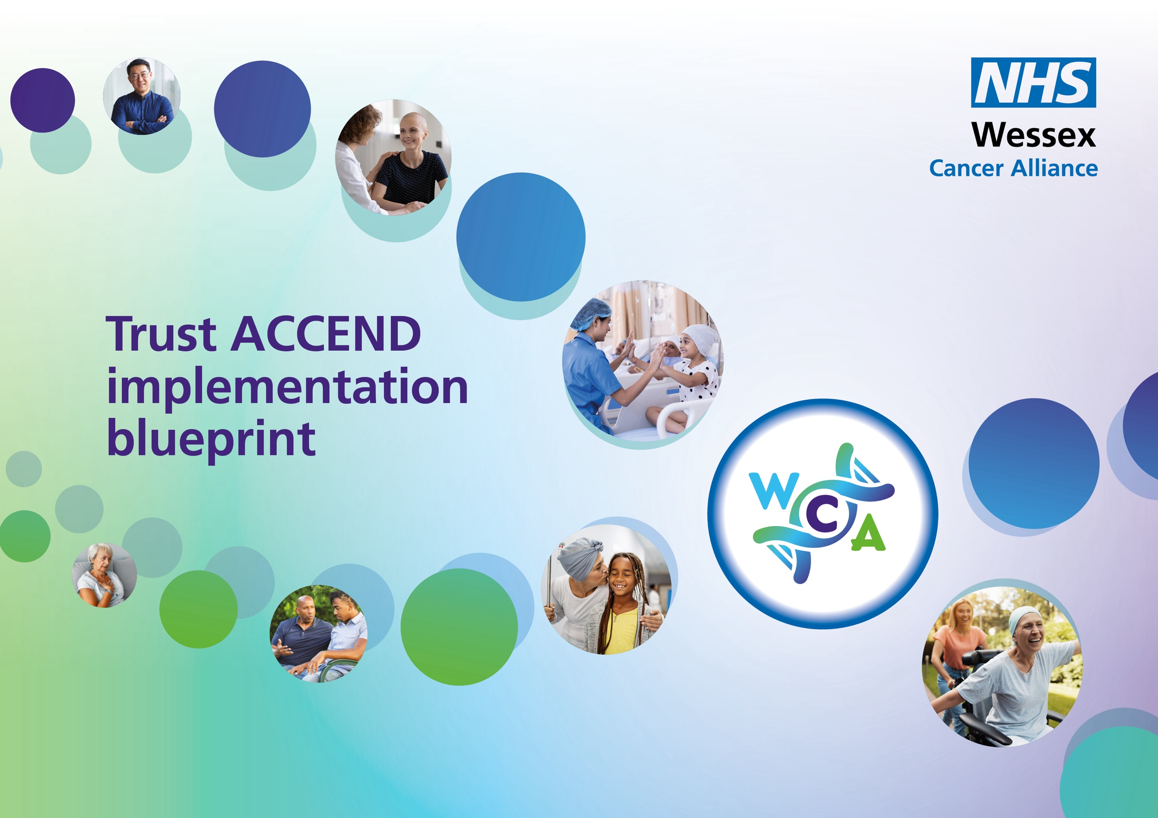

Summary Actions
Implementation area | Suggested activity | Quarter 1 | Quarter 2 | Quarter 3 | Quarter 4
Leadership and Governance | - Complete a stakeholder analysis of cancer services to identify key partners for implementation.  - Implement a Trust wide ACCEND Steering Group  - Write a communication plan to support implementation.  - Embed it into HR, education, line management, and recruitment processes.  - Create an environment that empowers staff to make ACCEND-led changes.  - Recruit an ACCEND Facilitator  - Provide quarterly reporting to the Alliance.
Role design | - Plan how you will embed ACCEND in  Recruitment  inductions  competency development  CPD planning
Job descriptions | - Work with their HR business partners to agree a coordinated approach to review relevant job descriptions to ensure consistency with the ACCEND Framework.
Appraisals | - Integrate the ACCEND Framework into appraisal processes to ensure that capability development, levels of practice, and education requirements are routinely reviewed and supported.
Education | - Provide clear, consistent expectations for cancer capabilities and education at supportive, assistive, registration, enhanced, advanced and consultant level roles.  - Provide or enable access to a range of learning opportunities aligned to ACCEND.  - Clear, equitable process for applying for CPD funding, education grants & other opportunities.  - Complete an annual training needs analysis at all levels.

