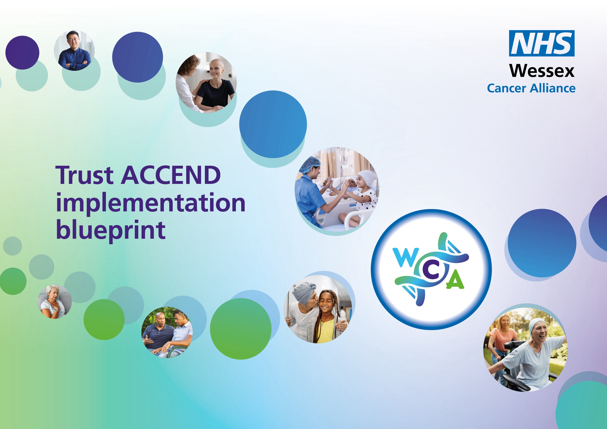

Supporting the implementation of the ACCEND Framework within organisations – Appraisal Template

ACCEND Development and Appraisal Conversations

The following are suggestions to support line managers and appraisees have meaningful discussion, focusing on career development, capability building, and aligning individual goals with the ACCEND framework:

Suggested Key Questions for Line Managers
- Which ACCEND level of practice is the appraisee currently working at, and is this accurately reflected in their role and responsibilities?
- What evidence has the appraisee provided to show progress against relevant ACCEND capabilities in practice (CiPs)?
- Are there any gaps in capability or confidence that require more support, supervision, or training?
- How can the organisation support the appraisee to achieve and maintain the required ACCEND capabilities?
- What are the appraisees career aspirations? What additional support or resources do they need?
- Have they got an ePortfolio account? Have they shared the record of their progress and development?

Suggested Key Questions for Appraisees
- Which ACCEND capabilities in practice do I feel most confident in, and what evidence can I provide to show this?
- Where do I feel I need further development, support, or training?
- What ACCEND-aligned education or learning opportunities would help me progress in my role or career pathway?
- What goals would I like to set for the coming year that align with my ACCEND level of practice and future ambitions?
- Have I downloaded the summary of my capability attainment, education & training from my ePortfolio?

AND/OR

ACCEND Aligned Appraisal Template

For discussion | Comments

Section 1: ACCEND Level of Practice

1.1 Current ACCEND Level of Practice -
1.2 Is the identified level of practice aligned to the job description?
1.3 Actions (if needed) –

Section 2: Review of ACCEND Capabilities in Practice (CiPs)

2.1 Evidence of Capability (Appraisee) -

Line Manager Comments -

2.2 Confidence and Capability Assessment (Appraisee) -

Line Manager Comments -

Section 3: Development Needs and Education Requirements

3.1 ACCEND‑Aligned Development Needs (Appraisee & Manager) -

3.2 Planned Education, Training, or Learning Activities-

Section 4: Career Progression and Aspirations

Appraisee Future Career Goals -

Line Manager Comments –

Section 5: Summary and Agreed Objectives

ACCEND‑Aligned Objectives for the Coming Year:

Support Required from Line Manager / Organisation:

Section 6: Sign‑Off | Appraisee Name & Signature:  Date:  Line Manager Name & Signature:  Date:

