Health Inequalities and Patient Experience (HIPE) Network
Inaugural Meeting Notes
19 March 2026
1. Welcome and Introductions
Sue Newell welcomed participants. The meeting was opened with the ‘Cancer Care for Everyone’ conference video as it inspired this network: https://youtu.be/5zjoQJlKuso
2. “Change One Thing” – Group Discussions
Everyone was invite to have conversations in a breakout group to share areas they are currently trying to improve in terms of health inequalities, including what these bring in terms of opportunities, challenges, and support needs.
Group Feedback:
Group 1: Need for sharing learning, work and contacts.
Group 2: Need help locating support; useful cross‑area connections.
Group 3: Great work happening but not widely known; avoid reinventing the wheel.
It is helpful to hear this as we can use the network to share practice and learning, as well as offer support and resources to members.
Action: Everyone to invite others that may be interested in joining the Network and to contact Sue to get the quarterly ‘Get Involved’ Newsletter.
3. Data and Insight Session
Emma Leatherbarrow presented local data, which shows:
- 60% higher cancer mortality in most deprived areas (CRUK data)
- Clear deprivation–late diagnosis correlation.
- There is an issue with data completeness issues (especially ethnicity), which is a result of how information is pulled into the Dorset Information and Insight System.
Sue also presented support available and recent and planned work around insight gathering, which builds on the data. Data often tells the ‘what’ but insight can help us find out the ‘why’ to be able to coproduce solutions from.
4. UHS Polish Women’s Gynaecological Cancer Experience Project
Sue Newell presented the work she did last year with UHS and a Polish Community Group about Polish women’s experiences of gynae cancer care and support.
- Case study (Anna) illustrated emotional and physical impact.
- Key findings: need for interpreting and translation is key throughout the patient journey, emotional support for patients and carers, and support for people’s faith. These are often transferable for speakers of other languages.
5. Shaping the Network
The group were asked for their ideas to help shape the network. These included: sharing case studies and have themed sessions, involving relevant guest speakers.
Sue asked people to complete a poll. The results were as follows:
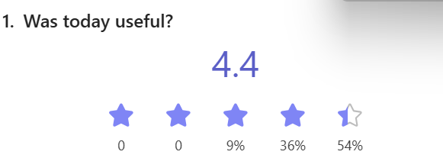
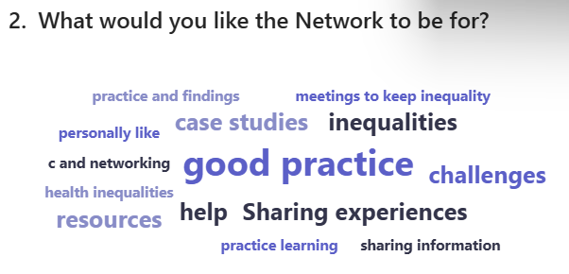
The majority of people wanted to meet quarterly and for a Wessex Cancer Alliance webpage to be set up to share information and resources.
Action: Everyone to share ideas for next meeting agenda items.

