Fast Track Urgent Suspected Cancer Referral: Skin

Date of decision to refer | ${createdDate} | Date referral received at Trust
Hospital selection | University Hospital Dorset (UHD)  Dorset County Hospital (DCH) |  | Salisbury NHS Foundation Trust  Other: ${hospitalSpecify}

PATIENT DETAILS | Surname: ${surname} First Name: ${firstname} Title: ${title}
PATIENT DETAILS | Sex assigned at birth: ${gender}  Gender Identity (if different from that above): ${genderIdentity}  (e.g. Male (inc trans man) / Female (inc trans woman) / Non-binary)
PATIENT DETAILS | DOB: ${dob} NHS Number: ${nhsNumber}
PATIENT DETAILS | Ethnicity: ${ethnicity}
PATIENT DETAILS | Patient Address: ${patientAddress}  Postcode: ${postcode}
PATIENT DETAILS | Contact numbers:  Home: ${home} Mobile: ${mobile} Preferred phone number: ${preferredPhoneNumber} Email: ${email}
PRACTICE DETAILS | Registered GP Name: ${usualName}
PRACTICE DETAILS | Practice Name: ${practiceName}
PRACTICE DETAILS | Direct line to the practice (Bypass): ${bypass}
PRACTICE DETAILS | Main: ${main} Fax: ${fax} Email: ${gpEmail}
PRACTICE DETAILS | Referring Clinician: ${referringClinical}

REFERRAL INFORMATION/CRITERIA
Please indicate whether your patient can go straight to a photo clinic (teledermatology). If not, they will be seen in the usual way.
Is your patient suitable for a photo clinic? Yes No Don’t know/Unsure

If you answered Don’t know/Unsure above, please state why: ${unsureIfSuitableForPhotoClinicDetail}

The following are suitable:
- There are no more than two skin lesions
- The lesion(s) can be clearly seen and identified by an HCA and accessed by a dermatoscope
The following are not suitable:
- Genital lesion
- Cannot see the base of the lesion easily on a photograph due to thick adherent crust
- Lesion requires dressing by a health professional
- Patient is unable to mobilise safely or manage their toilet needs
- Patient requires transport
- Patient has significant cognitive impairment impacting on their ability to consent Yes No
Melanoma | Squamous Cell Carcinoma | High Risk Basal Cell Carcinoma
Suspicious lesion scoring ≥ 3 on the weighted list (please mark)  MAJOR (scoring 2 points each)  Change in size  Irregular shape  Irregular colour  MINOR (scoring 1 point each)  Largest diameter ≥7mm  Inflammation  Oozing  Change in sensation  SCORE: ${score}  Pigmented or non-pigmented lesion suggestive of nodular melanoma  Dermoscopy findings suggestive of malignant melanoma  (Please describe findings below)  ${melanomaFindings} | Lesion is suspicious of a squamous cell carcinoma. | Concerning site or size (i.e. periocular involvement)  (Please specify special concern below)  ${bccConcern}  ONLY consider a 2ww referral if the skin lesion is suspicious of a BCC and delay in treatment may cause harm because of lesion site or size. In all other cases refer to routine dermatology service.

SYMPTOMS AND REASON FOR REFERRAL (ESSENTIAL)
${symptomsAndExaminationFindings}
.
.
.
Clinical description of the lesion:
Site ${skinLesionSite}

Size (mm) ${skinLesionSize}
Please indicate the site of the lesion(s) on the body map below (click on the image to mark the position).
Maximum 2 lesions for photo clinic, otherwise maximum 3 lesions.
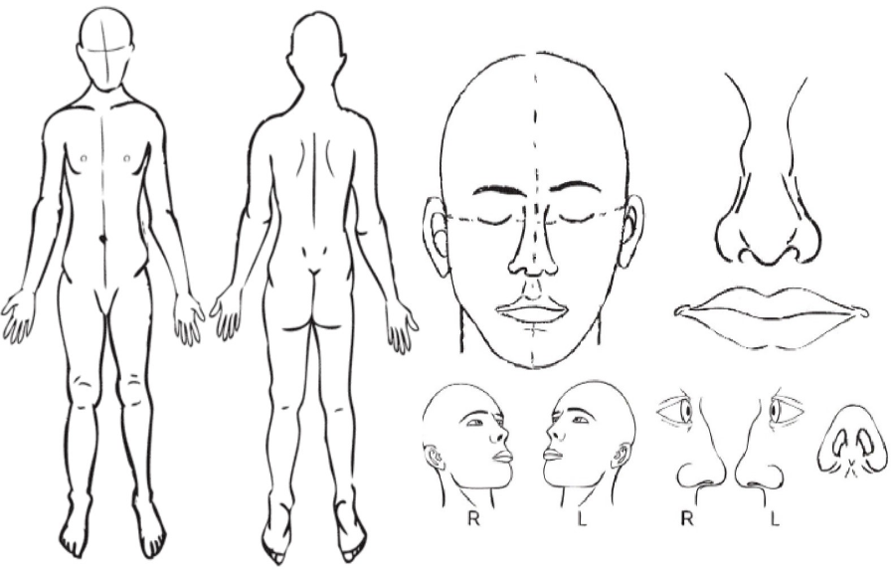

PATIENT INFORMATION
Please tick to confirm:
Patient is aware that this is a fast track referral to exclude cancer, that they are being referred to the rapid access suspected skin cancer clinic, and the nature of the tests likely to take place.
Patient has been provided with a fast track cancer pathway information leaflet or sent an electronic link. Leaflet available in different languages at: https://cancermatterswessex.nhs.uk/fast-track-referrals/
Patient is expecting to be contacted by secondary care within 2 weeks and knows who to contact if this doesn’t happen.
Patient is aware that if they are suitable for the Teledermatology pathway they will be invited to have their lesion photographed, after which a Consultant Dermatologist will review their images and they will be informed of the outcome and next steps by post/phone.
Patient is aware they will be offered the first available appointment at any of our hospitals/community diagnostic centres.

ACCESSIBILITY
Please tick any of the following that apply to your patient:
Patient has cognitive impairment that may affect their mental capacity for consent.
If yes, please confirm date best interests meeting completed: ${mentalCapacityDate}
Patient has significant mobility impairment (specify): ${mobilityImpairmentSpecified}
Patient has significant sensory impairment (specify): ${sensoryImpairmentSpecified}
Patient will require an interpreter (specify): ${language}
Patient requires hospital transport, please specify type: ${transportRequiredDetails}
Patient has a pacemaker or implantable cardioverter defibrillator (which may affect use of diathermy)

Rockwood Clinical Frailty Scale. Please tick most appropriate box:
ROCKWOOD CLINICAL FRAILTY SCALE (CFS)
1 - Very Fit  2 - Well  3 - Managing Well  4 - Vulnerable  5 - Mildly Frail | 6 - Moderately Frail  7 - Severely frail  8 - Very Severely frail  9 - Terminally ill
When scoring frailty in people with dementia the degree of frailty corresponds to the degree of dementia i.e. Mild dementia = CFS 5, Moderate dementia = CFS 6, Severe dementia = CFS 7

For more information:
https://www.england.nhs.uk/south/wp-content/uploads/sites/6/2022/02/rockwood-frailty-scale_.pdf

CLINICAL DETAILS
Details of other significant medical history:
${medicalHistory}

Anticoagulation and / or antiplatelet medication – please state indication, medication taken and latest INR if applicable:
${isAnticoagulatedWith}
${antiPlatelets}
${inr}

List or attach regular medication:
${medication}

Allergies:
${allergies}

