Autumn Cancer Awareness Campaign – September-November 2025

Primary Care toolkit


Introduction:
This toolkit is designed for use within Primary Care across Wessex to help raise awareness of the signs and symptoms of cancer, NHS cancer screening programmes and the importance of early diagnosis, as part of an Autumn Awareness campaign called ‘Know the Signs’. All information provided in this document can also be found in the Primary Care Toolkit on our website.
https://wessexcanceralliance.nhs.uk/primarycaretoolkit/awareness-campaigns/

Key Messages
The campaign will be focusing on three key messages:
- 1 in 2 people will get cancer in their lifetime
- Early cancer diagnosis saves lives
- If something in your body doesn’t feel right, speak to your GP Practice. Don’t carry the worry of cancer with you.

There is a lot of information that can be used alongside these messages, such as the common signs and symptoms that people should be aware of, the Cancer Screening programmes that can help prevent cancer and information about survival. Please check out our dedicated webpage, for links to further information and support that you may wish to share as part of this campaign: www.cancermatterswessex.nhs.uk/know-the-signs

Target Audience
For this campaign there are a number of audiences the messaging will be relevant to. Our key audiences are:
Men aged 50+
People/Communities in areas where the Index of Multiple Deprivation is High
Ethnic Minority Communities across Wessex

Messaging
Below is some suggested Bulletin/Newsletter/Web copy:

Short Copy:

Know the Signs

We are supporting Wessex Cancer Alliance with their awareness campaign, ‘Know the Signs’. The aim of this campaign is to improve people’s awareness of the signs and symptoms of cancer.

1 in 2 people will be diagnosed with cancer in their lifetime, so it is really important to know what signs to look out for and when to seek advice from your GP Practice.
Visit their dedicated website, for more information and support: www.cancermatterswessex.nhs.uk/know-the-signs

Long Copy:

Know the Signs

We are supporting Wessex Cancer Alliance with their awareness campaign, ‘Know the Signs’. The aim of this campaign is to improve people’s awareness of the signs and symptoms of cancer.

1 in 2 people will be diagnosed with cancer in their lifetime, so it is really important to know what signs to look out for and when to seek advice from your GP Practice.

We want to help people identify the warning signs and to know when to seek medical advice. If more people know the signs of cancer, then more will have a better chance of surviving their cancer.

Survival rates for cancer have improved so much over the last 50 years that we are now seeing approximately 50% of people diagnosed with cancer surviving for ten years or more – this is even more likely if the cancer is diagnosed at an early stage.

Some of the most common signs and symptoms of cancer are:
A new lump/bump that wasn’t there before.
Sudden, unexplained weight loss
Blood in your poo or your urine
Feeling tired all the time
Breathlessness
Bloating/swelling
Changes to your skin.
9 times out of ten, your symptoms will not mean you have cancer, but it is better to know as early as possible so you can rule out cancer or get the treatment you need, quickly.

For further information and links to advice and support please visit the dedicated website www.cancermatterswessex.nhs.uk/know-the-signs

Social Media
Below, are some suggested social media posts that you can use during the campaign. Please also follow our Cancer Matters Wessex Facebook page, and share our posts.

- We are supporting the latest campaign from Wessex Cancer Alliance; ‘Know the Signs’ raising awareness of the signs and symptoms of cancer. Find out more here. www.cancermatterswessex.nhs.uk/know-the-signs

- Do you know the signs and symptoms of cancer and when to seek advice? #KnowTheSigns www.cancermatterswessex.nhs.uk/know-the-signs
- 1 in 2 people will get cancer in their lifetime. Know the Signs and speak to your GP Practice if you have any concerns #KnowTheSigns www.cancermatterswessex.nhs.uk/know-the-signs
- Early cancer diagnosis saves lives, make sure you know the signs to look out for and speak to your GP practice if something doesn’t feel right. #KnowTheSigns www.cancermatterswessex.nhs.uk/know-the-signs
- Don’t carry the worry of cancer with you. If something in your body doesn’t feel right, speak to your GP Practice. Know the signs and keep a diary of your symptoms. This will help when you speak to a medical professional #KnowTheSigns www.cancermatterswessex.nhs.uk/know-the-signs

- You can speak to a pharmacist if you have any signs or symptoms that you are not sure about and they can help signpost you to the right service. Know the signs and speak to a health professional. www.cancermatterswessex.nhs.uk/know-the-signs

Social Media Tags:
Please tag us in your social media posts:
X (formerly Twitter)
@NHS_WCA
@CancerMatters
@NHSDorset
Facebook:
https://www.facebook.com/CancerMattersWessex
LinkedIn: https://www.linkedin.com/company/wessex-cancer-alliance

Assets for the campaign:
- Social media graphics
These can be downloaded from our website – previews below
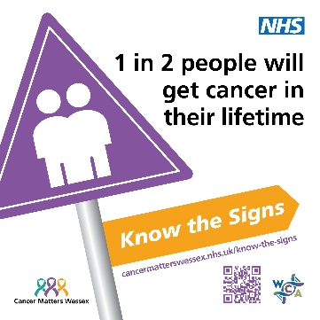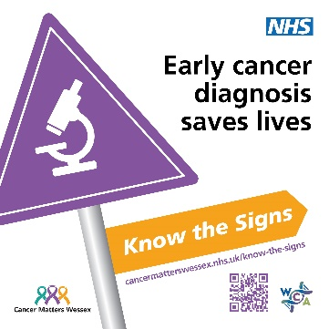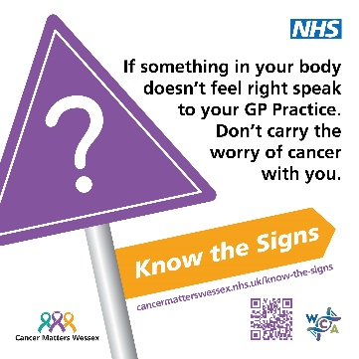
- GP Screen imagery
Please feel free to use the social media graphics on your GP Screen, or contact us if you require alternative sizing options to work on your screen
- Posters
We have designed posters for you to use in your surgery and local community – these can be downloaded from our website and printed by you, or get in touch with us to request printed copies’
(Download posters here: https://cancermatterswessex.nhs.uk/know-the-signs/)
- Patient videos
We have patient stories that can be shared as part of this campaign. We hope to add to these with content shared by some of the community groups supporting this campaign. Please regularly check the primary care toolkit for new content.
- Pharmacy Bags
We will be distributing ‘Know the Signs’ branded pharmacy bags to pharmacies to use in their stores to help promote the campaign.
- Leaflet Holders
We have had some branded leaflet holders designed for this campaign – please contact us if you would like one for your pharmacy or GP Practice (we can also supply some leaflets to go in them!)
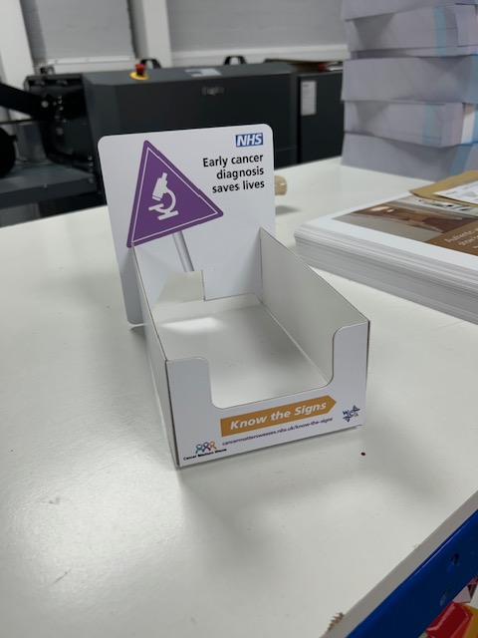

Further information/Resources
Urgent Suspected Cancer Referrals (Fast Track Referrals) – We have a dedicated page with details for patients about what they can expect if they are referred by their GP for a suspected cancer. Please share this link with any patients you refer: https://cancermatterswessex.nhs.uk/fast-track-referrals/
Support for patients from Charities: There are numerous cancer charities that can support and advise someone who is diagnosed with cancer or awaiting a diagnosis. Some of these are generic cancer support and others are for specific types of cancer. There are also many resources that can be downloaded, printed or ordered for delivery, to support awareness raising. You can check out our website for more links to support and charities. https://cancermatterswessex.nhs.uk/
Cancer Screening: We have dedicated pages on our website, that explain the different Cancer Screening programmes available on the NHS in the UK. Please consider linking to these pages and encourage patients to take up their invitation for Screening. https://cancermatterswessex.nhs.uk/cancer-screening-and-prevention/

